Fundamental Study:
Experimenting the pitot tube setup for accurate measurement.
Tests Run:
Air Testing
To investigate the behavior of the differential sensor we used a vacuum to create velocity in the air to view how the sensor would react. To test this we took data over a 3-minute period. First, we started at rest, then at 60 seconds we turned on the vacuum creating a signal, then after 60 seconds we turned the vacuum off.
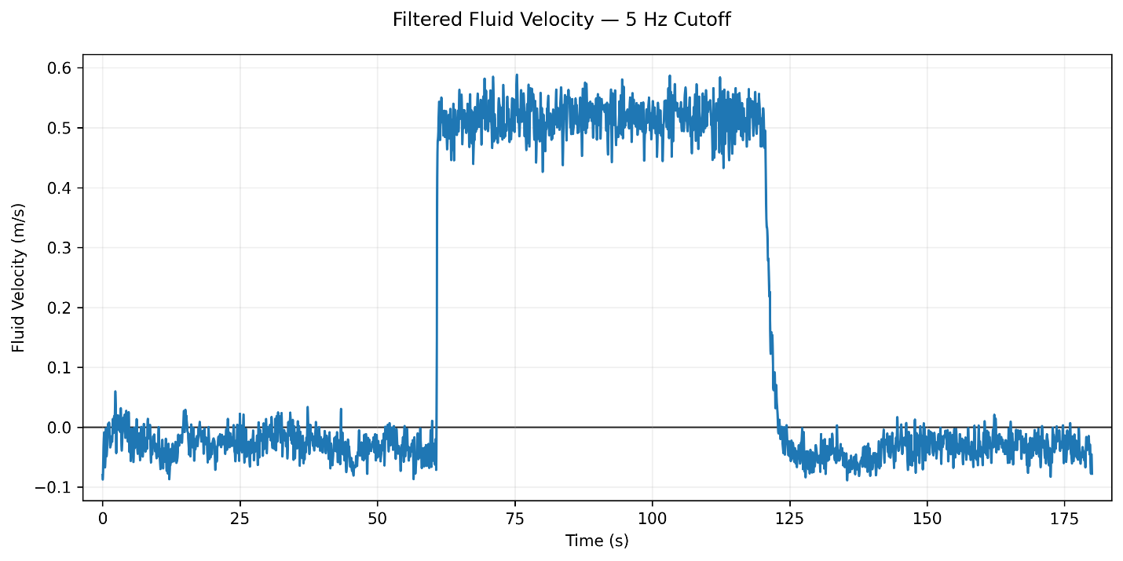
The sensor predictably increased when the motor was on, but then decreased when the motor was off. What these tests tell us is that the sensor and setup has some reliability to detect changes in velocity, but there is something different when using the water. We then replicated the test but in water to try and produce a clean signal like what was done in air.

Water Testing
When placing the pitot tube in the water we received lots of different data most likely due to water simply entering the pitot tube in the transition from air to water. The placement of the pitot tube recorded lots of variable data. To counter this, we initially redid the tubing of the pitot tube to ensure secure connections to prevent leakage. Also, we thought to first place the pitot tube in the water, then depress a syringe on the ends of the pitot tube to eliminate any bubbles that could appear in the pitot tube.
We placed the pitot tube at the middle of the water level. We then ran the test that was done in air. First, the tank water was at rest, then we turned on the motor at 60 seconds, then we turned off the motor at 60 seconds.
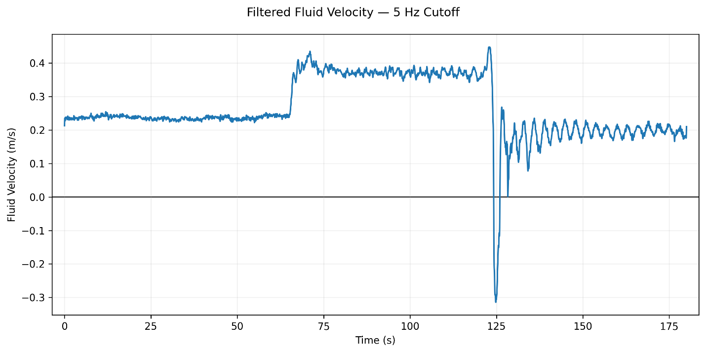
Previous tests we saw the gradual decrease in the velocity even when the motor was running. We believe securing the tubing did help mitigate this effect. The sensor setup is slightly improved, but we still see the wave formation with the membrane at the tank. These tests show that we need a specific method for consistency with the sensor since many factors can change the data as the testing on 8-4 showed.

